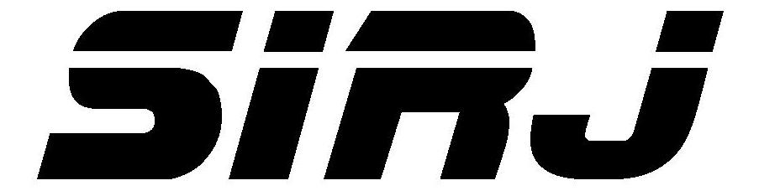
Offender’s name:
Case number:
Salina Initiative for Restorative Justice
P.O. Box 3354 Salina, KS 67402-3354

NEIGHBORHOOD ACCOUNTABILITY BOARD
PARTICIPATION AGREEMENT

I acknowledge and agree that the Neighborhood Accountability Board process is a voluntary and confidential process in which I consent to participate. No conclusions reached or decisions made will be forced on any participant. Any conclusions reached or decisions made will be determined by the parties’ mutual agreement.

In the event that final resolution is not reached at this meeting, I agree that I will not use anything that is said here by the other parties in any future legal proceedings.

I understand that SIRJ will keep the records of this session strictly confidential to the fullest extent possible under law. I further agree that I will not involve the board or records of this meeting in any court proceeding that might arise in the future.

Signatures:

Victim Date
Board member Date
Board member Date
Board member Date
Board member Date
Offender Date
Other Date
Other Date
SIRJ Mediator Date

